[https://www.mentesenblanco-razonamientoabstracto.com](view-source:http://www.mentesenblanco-razonamientoabstracto.com/)

# Test 1

### *By Omar Castaño P.*

You will find the correct answers at the end of the test.

Change the box with the question marks (**???**) by one of the three on the right side (**a**,**b**,**c**):

1. test1-1
2. test1-2
3. test1-3

1. test1-4
2. test1-5

1. test1-6
2. test1-7
3. test1-8
4. test1-9
5. test1-10

**Answers:**

(01.**b**) (03.**a**) (05.**a**) (07.**c**) (09.**c**)

(02.**b**) (04.**a**) (06.**b**) (08.**a**) (10.**b**)

# Test 2

### By Omar Castaño P.

You will find the correct answers at the end of the test. Change the box with the question marks (**???**) by one of the three on the right side (**a**,**b**,**c**):

01. 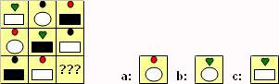

02. test2-2

03. 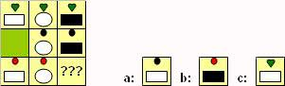

04. 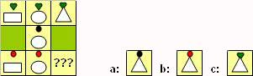

05. test2-5

06. test2-6

07. test2-7

08. test2-8

09. 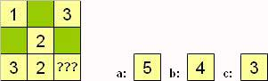

10. test2-10

[https://www.mentesenblanco-razonamientoabstracto.com](view-source:http://www.mentesenblanco-razonamientoabstracto.com/)

Answers:

(01-b) (02-b) (03-b) (04-b) (05-c) (06-c) (07-b) (08-c) (09-a) (10-a)

[https://www.mentesenblanco-razonamientoabstracto.com](view-source:http://www.mentesenblanco-razonamientoabstracto.com/)

# Test 3

### *By Omar Castaño P.*

You will find the correct answers at the end of the test.

Change the box with the question marks (**???**) by one of the three below with (**a**,**b**,**c**):

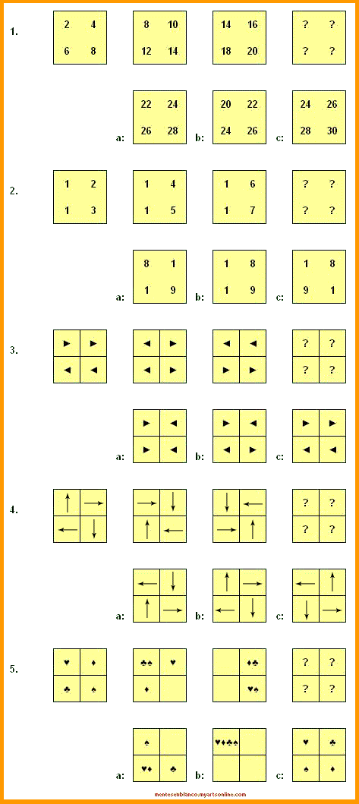

Answers: (01.b) (02.b) (03.a) (04.c) (05.a)

[https://www.mentesenblanco-razonamientoabstracto.com](view-source:http://www.mentesenblanco-razonamientoabstracto.com/)

# Test 4

### *By Omar Castaño P.*

You will find the correct answers at the end of the test.

Change the box with the question marks (**???**) by one of the three on the right side with (**a**,**b**,**c**):

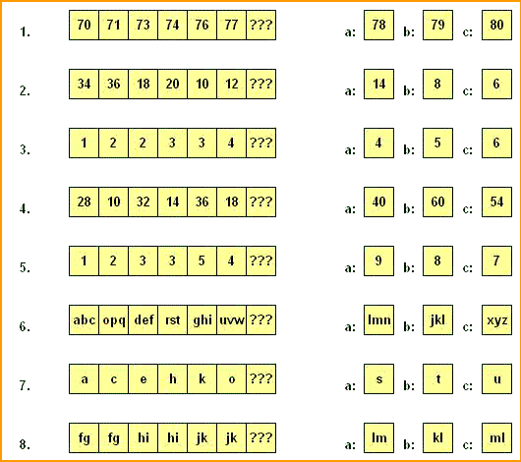

Answers: (01.**b**) (03.**a**) (05.**c**) (07.**a**)

(02.**c**) (04.**a**) (06.**b**) (08.**a**)

[https://www.mentesenblanco-razonamientoabstracto.com](view-source:http://www.mentesenblanco-razonamientoabstracto.com/)

# Test 5

### *By Omar Castaño P.*

You will find the correct answers at the end of the test.

Change the box with the question marks (**???**) by one of the three on the right side with (**a**,**b**,**c**):

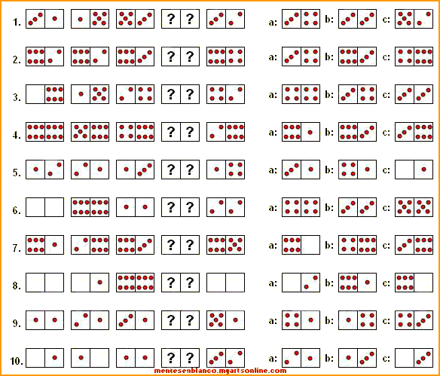

Answers: (01.**b**) (03.**c**) (05.**a**) (07.**b**) (09.**a**)

(02.**b**) (04.**c**) (06.**c**) (08.**b**) (10.**a**)

<https://www.mentesenblanco-razonamientoabstracto.com>

# Domino Series Test 2

### *By Omar Castaño P.*

You will find the correct answers at the end of the test.

Change the token with the question marks (??) for one of the three possible answers (a, b, c):

1. 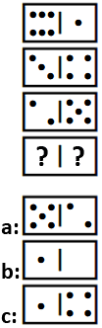

1. 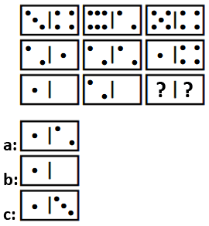
2. 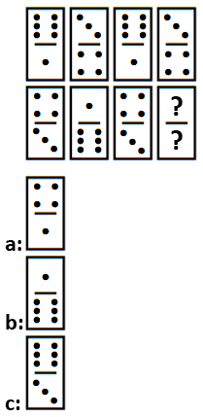
3. 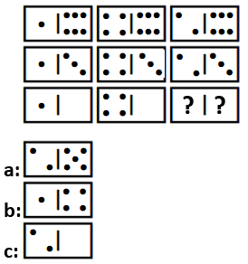
4. 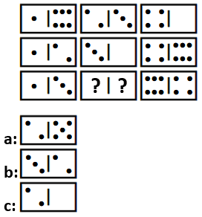

Answers: (01.**a**) (02.**a**) (03.**b**) (04.**c**) (05.**c**)

<https://www.mentesenblanco-razonamientoabstracto.com>

**Domino Series Test 3**

***By Omar Castaño P.***

You will find the correct answers at the end of the test.

Change the token with the question marks (??) for one of the three possible answers (a, b, c):

1. 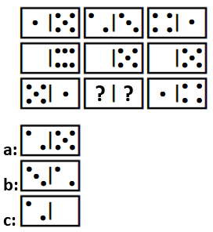

2. 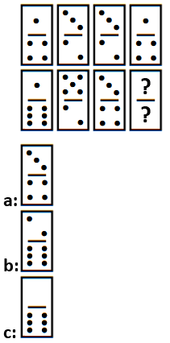

3. 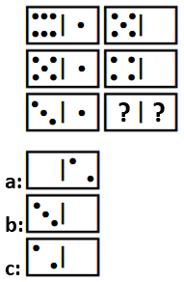

4. 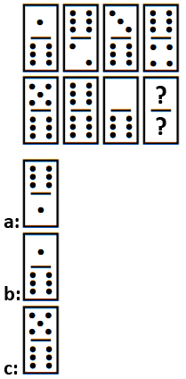

5. 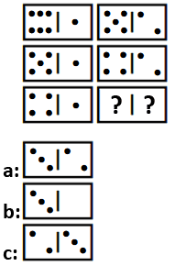

6. 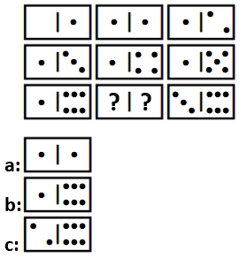

Answers: (01.**b**) (02.**a**) (03.**c**) (04.**a**) (05.**a**) (6.**c**)

[https://www.mentesenblanco-razonamientoabstracto.com](view-source:http://www.mentesenblanco-razonamientoabstracto.com/)

# Test 6

### *By Omar Castaño P.*

You will find the correct answers at the end of the test.

Which of the Answer Figures (**a**,**b**,**c**) belongs in NEITHER group:

Group A Group B

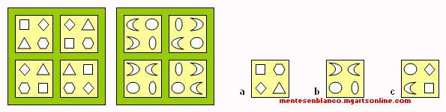

Group A Group B

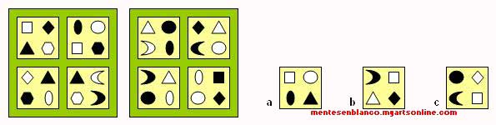

Answers:

1. **c**.

Group A shapes are all straight lines.

Group B shapes are all curved.

2. **a**.

(Group A) Same color shapes are diagonally opposite.

(Group B) Same color shapes are above/below.

[https://www.mentesenblanco-razonamientoabstracto.com](view-source:http://www.mentesenblanco-razonamientoabstracto.com/)

# Test 7

### *By Omar Castaño P.*

You will find the correct answers at the end of the test.

Change the box with the question marks (**???**) by one of the three on the right side (**a.b.c**):

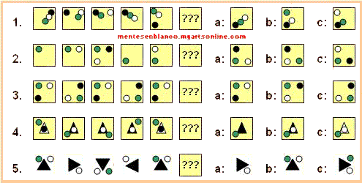

Answers: (01.**b**) (02.**a**) (03.**c**) (04.**b**) (05.**a**)

# Abstract Reasoning Test 8

### *By Omar Castaño P.*

Choose the figure that is not related with the other ones (a,b,c,d):

See correct answers at the end of the test. As always, if you have got any doubt about the answers, please contact us:

[https://www.mentesenblanco-razonamientoabstracto.com](view-source:http://www.mentesenblanco-razonamientoabstracto.com/)

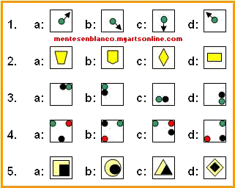

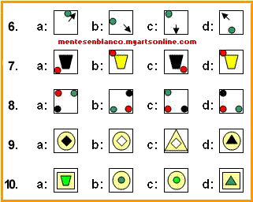

Answers: (01.c) (02.b) (03.c) (04.d) (05.d) (06. c) (07. c) (08. d) (09. d) (10. d)

# Abstract Reasoning Test 9

### *By Omar Castaño P.*

You will find the correct answers at the end of the test.

Change the cards with the question marks (**???**) by the ones on the right side (**a**,**b**,**c**):

As always, if you have got any doubt about the answers, please, contact us:

[https://www.mentesenblanco-razonamientoabstracto.com](view-source:http://www.mentesenblanco-razonamientoabstracto.com/)

1.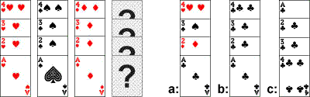

2.Test de Razonamiento Abstracto

3.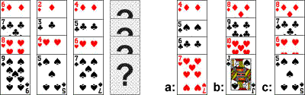

4.Test de Razonamiento Abstracto

5.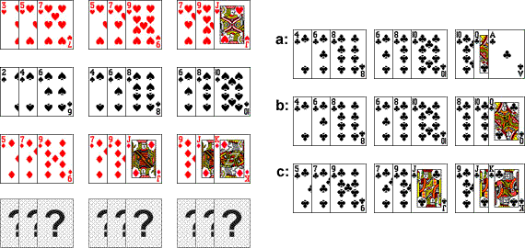

Answers: (01.b) (02.b) (03.b) (04.c) (05.b)

# Abstract Reasoning Test 10

### *By Omar Castaño P.*

Change the box with the question marks (**???**) by one of the three on the right side with (**a**,**b**,**c**):

See correct answers at the end of the test.

As always, if you have got any doubt about the answers, please, contact us:

[https://www.mentesenblanco-razonamientoabstracto.com](view-source:http://www.mentesenblanco-razonamientoabstracto.com/)

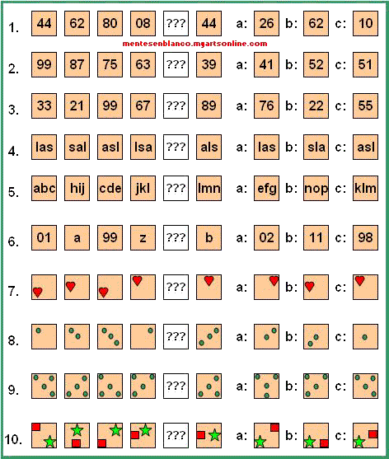

Answers: (01.**a**) (02.**c**) (03.**c**) (04.**b**) (05.**a**) (06.**a**) (07.**b**) (08.**a**) (09.**c**) (10.**a**)

# Test 11: Abstract Reasoning

### By Omar Castaño P.

[https://www.mentesenblanco-razonamientoabstracto.com](view-source:http://www.mentesenblanco-razonamientoabstracto.com/)

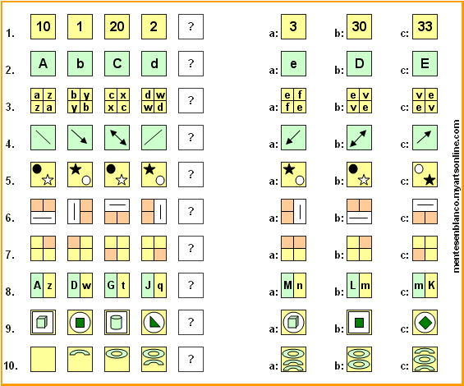

Answers:

1. b) (02. c) (03. b) (04. a) (05. b) (06. b) (07. b) (08. a) (09. c) (10. b)

# Test 12: Abstract Reasoning

### By Omar Castaño P.

[https://www.mentesenblanco-razonamientoabstracto.com](view-source:http://www.mentesenblanco-razonamientoabstracto.com/)

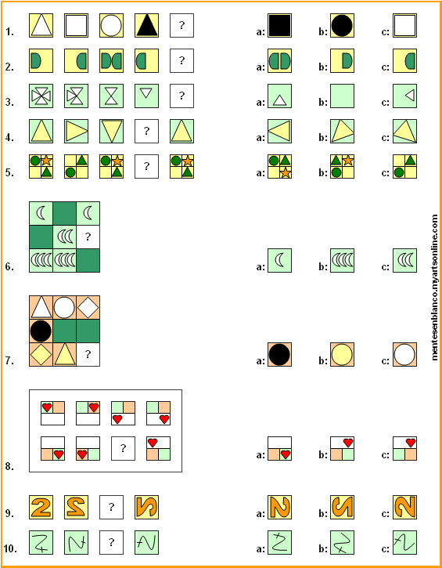

Answers:

(01. a) (02. b) (03. b) (04. a) (05. c) (06. c) (07. b) (08. b) (09. c) (10. a)

# Test 13: Abstract Reasoning

### By Omar Castaño P.

[https://www.mentesenblanco-razonamientoabstracto.com](view-source:http://www.mentesenblanco-razonamientoabstracto.com/)

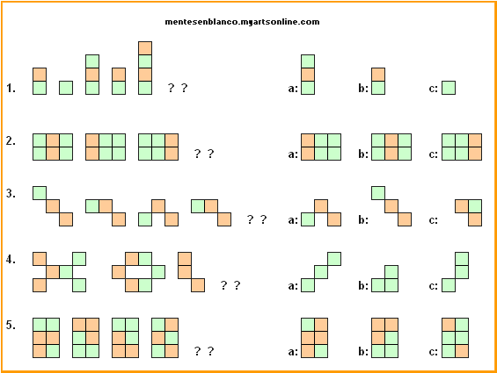

Answers:

(01. a) (02. b) (03. b) (04. c) (05. b)

# Test 14: Abstract Reasoning

### By Omar Castaño P.

[https://www.mentesenblanco-razonamientoabstracto.com](view-source:http://www.mentesenblanco-razonamientoabstracto.com/)

1. 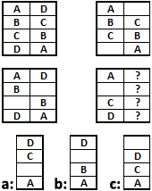 2. 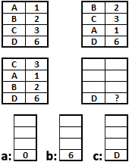

3. 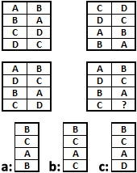 4.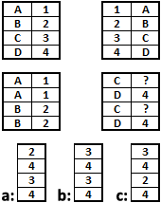

5.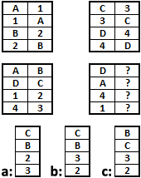

Answers:

(01. a) (02. a) (03. c) (04. b) (05. b)

Test 15:

[https://www.mentesenblanco-razonamientoabstracto.com](https://www.mentesenblanco-razonamientoabstracto.com/)

Check only one response

See correct answers at the end of the test.

Use the following diagram to find out the correct answers:

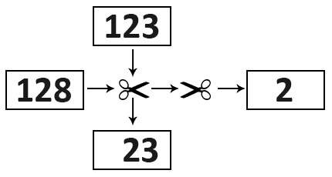

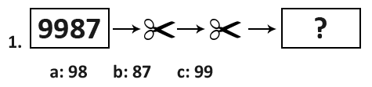

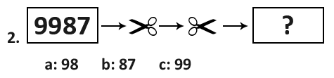

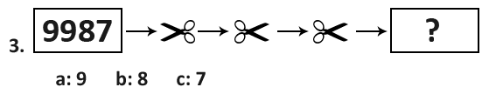

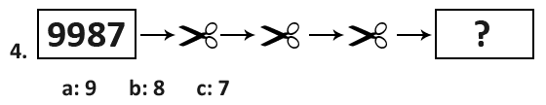

Answers Test 15:

Test 15:

(01. b)

(02. a)

(03. b)

(04. a)

Cuando las tijeras cortan hacia la derecha, se elimina el primer dígito de la izquierda.  
When the scissors cut to the right, the first digit on the left is removed.  
Quando a tesoura corta para a direita, o primeiro dígito da esquerda é removido.  
Lorsque les ciseaux coupent à droite, le premier chiffre à gauche est supprimé.  
当剪刀向右剪时，左边的第一个数字被删除。  
Quando le forbici tagliano a destra, la prima cifra a sinistra viene rimossa.

Cuando las tijeras cortan hacia la izquierda, se quita el primer dígito de la derecha.  
When the scissors cut to the left, the first digit on the right is removed. Quando a tesoura corta para a esquerda, o primeiro dígito da direita é removido.  
Lorsque les ciseaux coupent vers la gauche, le premier chiffre à droite est supprimé.  
当剪刀向左剪时，右边的第一个数字被删除。  
Quando le forbici tagliano a sinistra, la prima cifra a destra viene rimossa.

[https://www.mentesenblanco-razonamientoabstracto.com](https://www.mentesenblanco-razonamientoabstracto.com/)



**kent.ac.uk/ careers/ psychotests .htm**

# Test de Razonamiento No Verbal de la Universidad de Kent

**01-**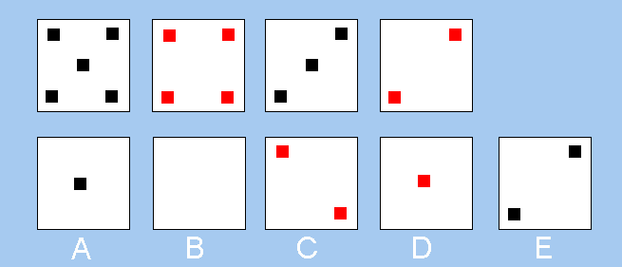

**02-**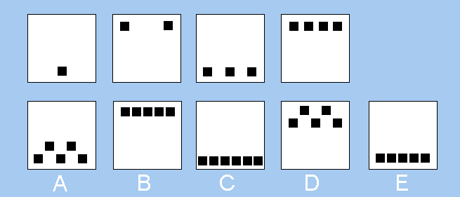

**03-**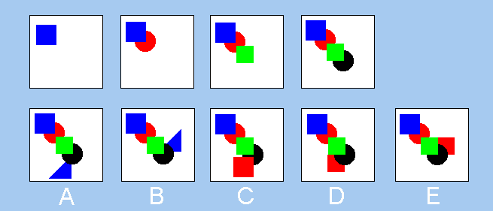

**04-**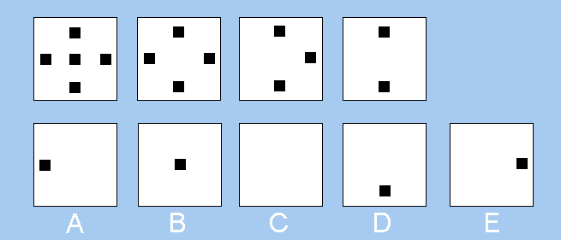

**05-**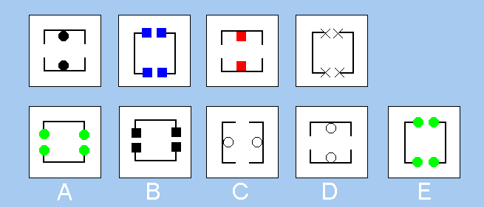

**06-**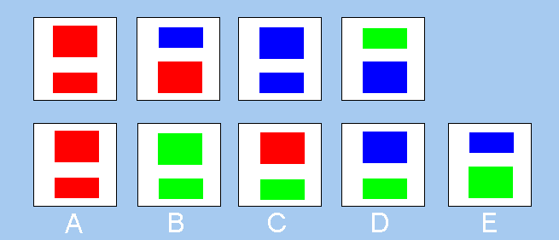

**07-**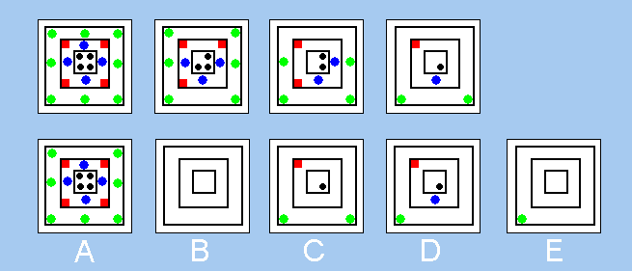

**08-**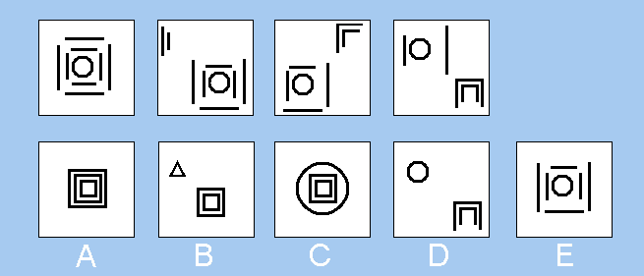

**09-**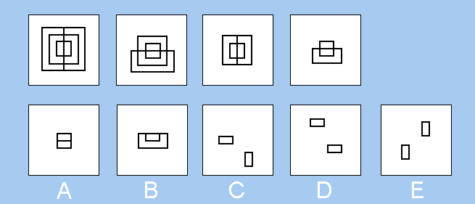

**10-**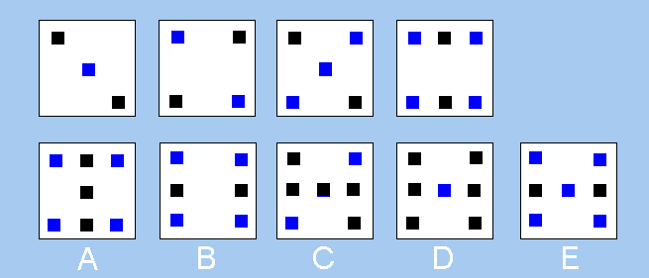

**11-**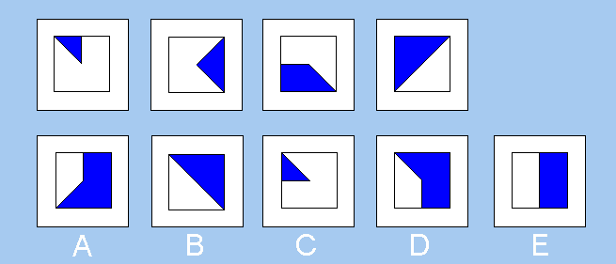

**12-**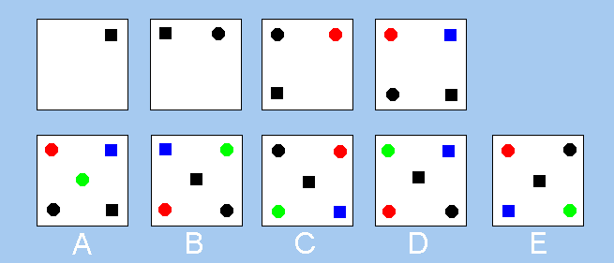

**13-**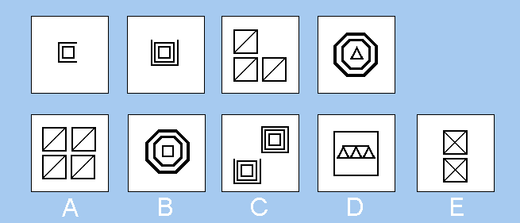

**14-**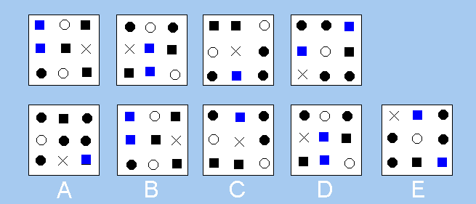

**15-**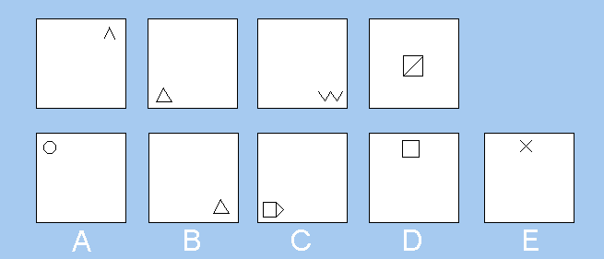

**16-**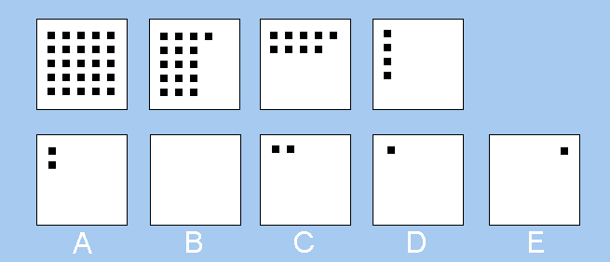

**17-**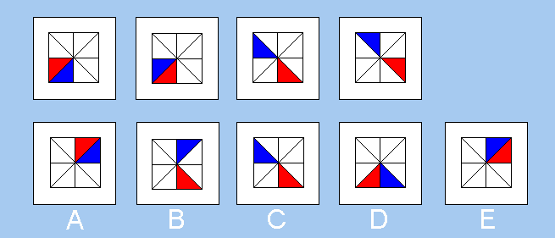

**18-**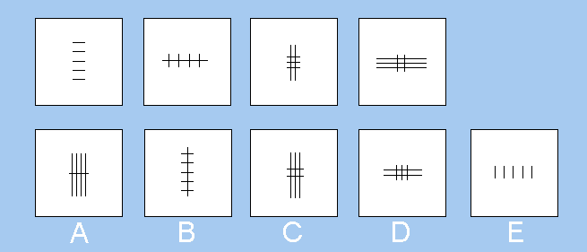

**19-**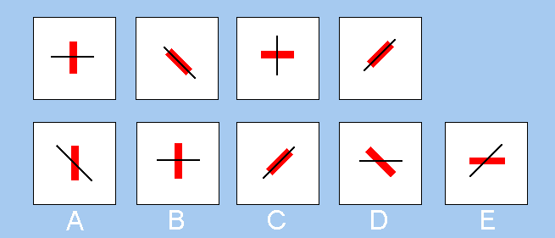

**20-**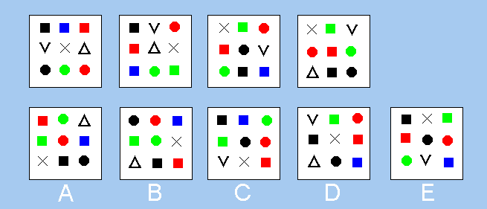

**Answers**

**How to work out the answers**

1) 5 black, 4 red, 3 black, 2 red, 1 black: A is the answer.

2) 1 black at bottom, 2 black top, 3 black bottom, 4 black top, 5 black at bottom: E is the answer.

3) blue square,   
blue square + red circle underneath,   
blue square + red circle + green triangle on top,   
blue square + red circle + green triangle + black circle underneath,   
blue square + red circle + green triangle + black circle + red square on top: C is the answer.

4) Each time one dot is removed so the last box should show one dot. This must be answer D, as it is the only box with a dot in the same location (South) as in the previous box.

5) E & W openings in the square, plus one object at N & S  
N & S openings, plus 2 objects at N & S  
E & W openings, plus one object at N & S  
N & S openings, plus 2 objects at N & S  
E & W openings, plus one object at N & S: D is the answer.

6) In each consecutive box one rectangle changes colour. A new colour introduced in a previous box will colour both rectangles in the next box.  
Red Red  
Red Blue  
Blue Blue  
Blue Green  
Green Green: B is the answer.

7) 8 green dots, 4 red, 4 blue, 4 black  
6 green dots, 3 red, 3 blue, 3 black  
4 green dots, 2 red, 2 blue, 2 black  
2 green dots, 1 red, 1 blue, 1 black  
0 green dots, 0 red, 0 blue, 0 black: B is the answer.

8) Each box contains 8 straight lines and a circle.  
Only answer C contains 8 straight lines and a circle.

9) The innermost two rectangles are vertical, then horizontal, then vertical again, then horizontal,   
So, in the answer they must both be vertical; therefore, E is the answer.

10) One blue square, then two blue squares, then three, then four; so, there must be five blue squares in the answer, which is E.

11) Each box increments by one blue segment (one eight of the square). So, there are 4 segments in box four (half the square is filled).   
So, there must be 5 blue segments (5/8th of the square) in the answer, which leaves us with A or D.  
But, the diagonal edge of the first segment is also rotating clockwise by 90% each time, so, it should be aligned NW in the answer. Therefore, the answer is D.

12) Items are introduced in this order: black square, black dot, red dot, blue square, green dot. New items are always introduced into the top right corner; therefore, B is the answer.

13) The first box has 7 straight lines, the second 11, the third 15, the fourth 19, and so the fifth box will have 23 lines; so, the answer is C.

14) The first box has one black dot, the second 2, the third 3, the fourth 4 and so; the fifth box will have five black dots, so, the answer is A.

15) The first box has two lines, the second 3, the third 4, the fourth 5 and so; the fifth box will have six lines, so, the answer is C.

16) The first square has 25 black squares, the second has 16, the third 9, the fourth 4 and so, the 5th will have one square (reducing sequence of the square numbers 25, 16, 9, 4, 1). Also, squares are removed from the right and from the bottom; so, the final square will be in the top left corner; thus, the answer is D.

17) The red triangle rotates anticlockwise by one segment each box. The blue triangle rotates by one segment clockwise each box; so, the answer is E.

18) The first box has 5 short lines and no long lines, the second box: 4 short & 1 long, the third box: 3 short & 2 long, the fourth box, 2 short and 3 long. So, each time there is one more long line and one less short line; so, in the fifth box there will be 1 short and 4 long lines: the answer is A.

19) The black line rotates by 45 degrees clockwise each time. The thick red line rotates 45 degrees anticlockwise each time, so, the answer is B.

20) The hardest question! Each time, a shape is removed and replaced by a different shape. The shape to be removed is always directly below the V shape (it points towards the next shape to be removed). So, the next shape to be removed would be the green circle; so, the answer is D.

Thanks for your visit.

[https://www.mentesenblanco-razonamientoabstracto.com](view-source:http://www.mentesenblanco-razonamientoabstracto.com/)

For People with Great Ideas